**DAILY ONLINE ACTIVITIES SUMMARY**

|  |  |  |  |  |  |  |  |  |
| --- | --- | --- | --- | --- | --- | --- | --- | --- |
| **Date:** | **19th May 2020** | | | | | **Name:** | **Dsouza Elston Ronald** | |
| **Sem & Sec** | **6th A section** | | | | | **USN:** | **4AL17CS029** | |
| **Online Test Summary** | | | | | | | | |
| **Subject** | | **Computer Graphics and Visualization(CGV)** | | | | | | |
| **Max. Marks** | | **60** | | **Score** | | | **51** | |
| **Certification Course Summary** | | | | | | | | |
| **Course** | **Full Stack Web Developer-Beginner to Advanced** | | | | | | | |
| **Certificate Provider** | | | **Udemy** | | **Duration** | | | **20 hours** |
| **Coding Challenges** | | | | | | | | |
| 1. **Problem Statement: 1..** We have a Letter or a word then we need add some letters to it and need to find out shortest palindrome For example we take "S": S will be the shortest palindrome string. If we take "xyz": zyxyz will be the shortest palindrome string So we need to add some characters to the given string or character and find out what will be the shortest palindrome string by using simple java program. 2. Write a simple code to identify given linked list is palindrome or not by using stack. | | | | | | | | |
| **Status: Completed** | | | | | | | | |
| **Uploaded the report in Github** | | | | | **Yes** | | | |
| **If yes Repository name** | | | | | <https://github.com/alvas-education-foundation/Elston-Dsouza-4al17cs029-> | | | |
| **Uploaded the report in slack** | | | | | **Yes** | | | |

Online Test Details: (Attach the snapshot and briefly write the report for the same)

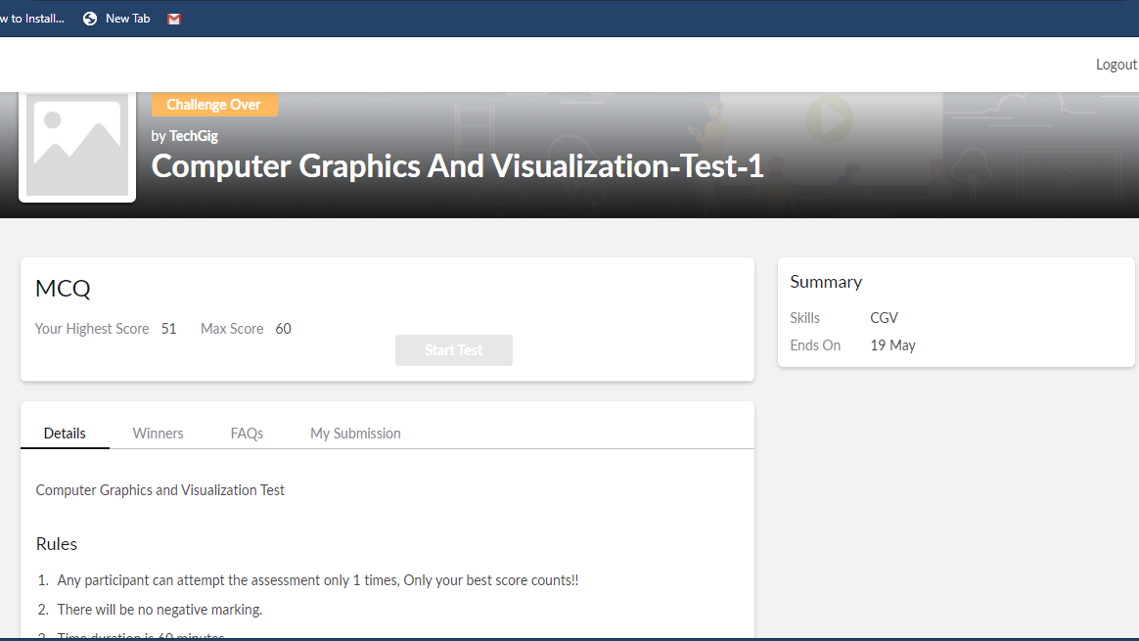

The above assessment was done by me on 19th May 2020 from 9 to 10 am and the details of assessment is as above.

Certification Course Details: (Attach the snapshot and briefly write the report for the same)

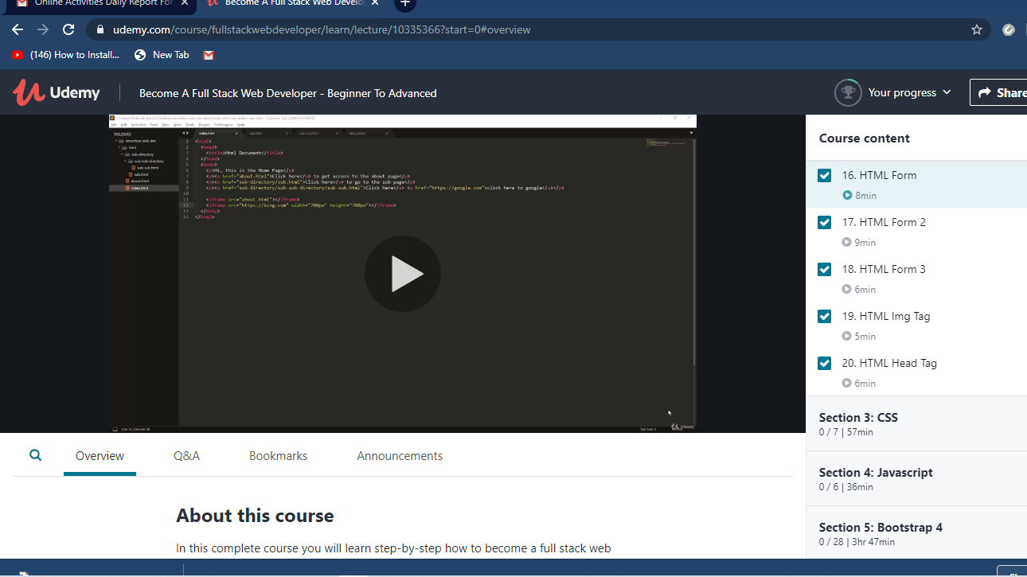

The above course is being taken up by me which is based on full stack web development. The course has started with the HTML basics as well as the various concepts in HTML. The details of the course and certificate provider is mentioned in the above form.

Coding Challenges Details: (Attach the snapshot and briefly write the report for the same)

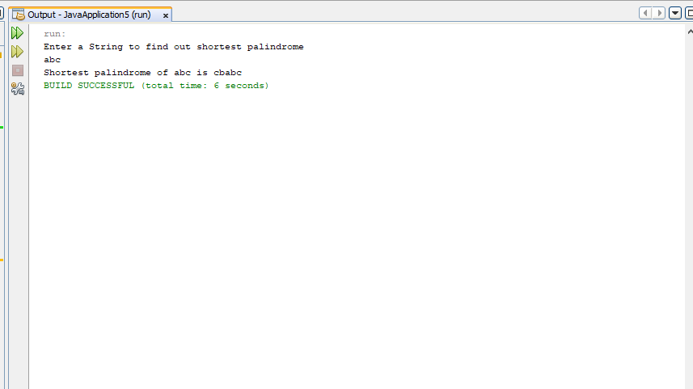

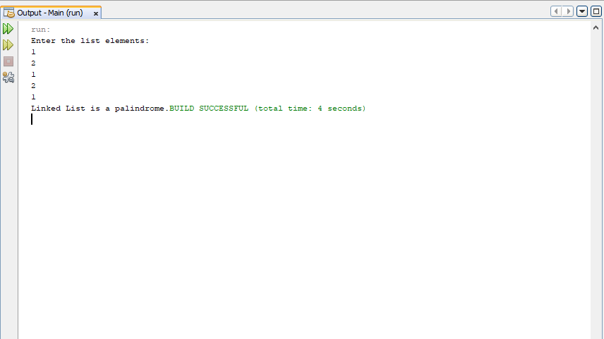

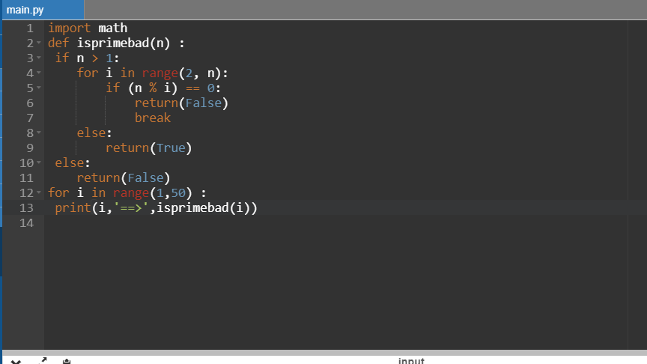

The above the programs were written and executed and the output of the same is displayed above. The code for the given 3 programs have been uploaded to the github repository and the link to the same is provided on the form.